|  |  |
| --- | --- |
|  |  |

|  |  |  |
| --- | --- | --- |
|  |  |  |

**Resistor Color Chart**

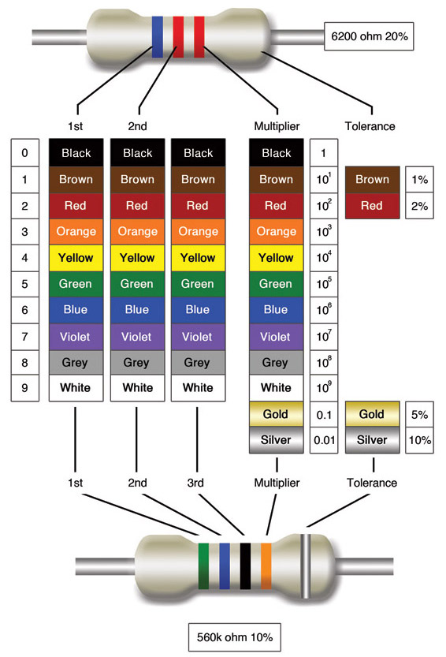

*Note:* The gold and silver band is only for tolerance. The band would be on the right side when reading.